Week 12

Test security of UPI applications on Desktop sharing applications.

Aim
To test the security of UPI applications when used on desktop screen-sharing applications such as TeamViewer and AnyDesk.

Input
- Smartphone with Internet connection
- UPI applications: Google Pay, Paytm, PhonePe
- Desktop/laptop
- TeamViewer and AnyDesk
Step 1:
Download and install UPI application on your phone
Download and install Teamviewer on your phone and computer Download and install Anydesk on your phone and computer

Step 2:
Start Screen sharing mobile phone with desktop system.
Test the security of the application and fill the table (keep adding more applications as you test)

List of UPI Apps

UPI Apps
GPay
Paytm
PhonePe

Sharing Apps
Team Viewer
Any Desk

Result
The security of the selected UPI applications was tested during mobile screen sharing with the desktop, and the security observations were recorded for each application.
Output:-
GPay :-
Security:Low security because Everything can be done while screen sharing

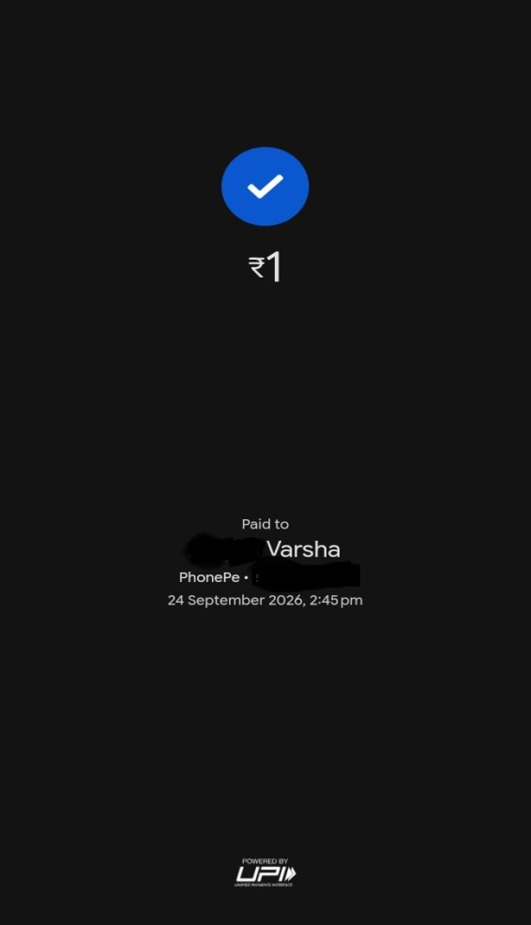

PhonePe:-
Security: Medium Security app is viewed but this payment process can’t be done due to screen sharing.

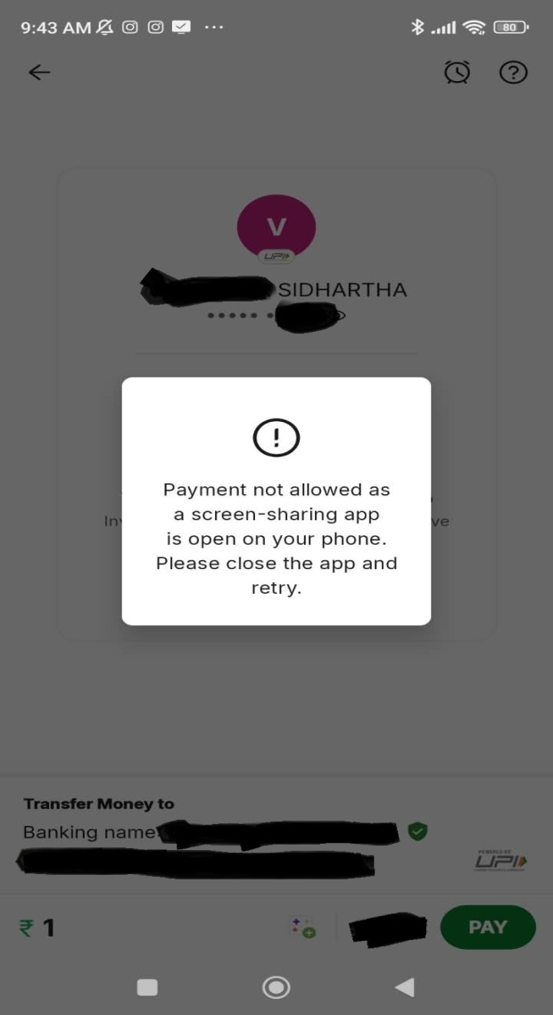
Paytm:-
Security: High security app as it doesn’t open while screen sharing.

